MAWLANA BHASHANI SCIENCE AND TECHNOLOGY UNIVERSITY
SANTOSH, TANGAIL-1902



DEPARTMENT OF INFORMATION AND COMMUNICATION TECHNOLOGY
Lab Report

Lab Report No : 02
Lab Report on : Study of linear convolution of discrete-time signals using MATLAB.
Course Title : Digital Signal Processing Lab
Course Code : ICT-3206

Submitted By | Submitted To
Name: Kuldip Saha Mugdha  ID: IT-22018  3rd Year, 2nd Semester  Session: 2021-2022  Dept. of ICT, MBSTU | Dr. Mst. Nargis Akter  Professor  DEPARTMENT OF INFORMATION AND COMMUNICATION TECHNOLOGY  MAWLANA BHASHANI SCIENCE AND TECHNOLOGY UNIVERSITY

Date of Performance: 28/10/25 Date of Submission: 16/11/25
Introduction:
Convolution is a fundamental operation in Digital Signal Processing used to determine the output of a linear time-invariant (LTI) system for a given input. Linear convolution can be performed directly in time domain, via circular convolution, and using the Discrete Fourier Transform (DFT). This experiment demonstrates different methods of performing linear convolution using MATLAB.

Objective:
- To perform linear convolution of two discrete-time sequences.
- To obtain linear convolution using circular convolution.
- To perform linear convolution using DFT and IDFT.

Theory:
The linear convolution of two discrete-time signals $x(n)$and $h(n)$is defined as
$$y(n)=\sum_{k=-∞}^{∞}{x(k)h(n-k)}$$
- Direct convolution is performed using the conv() function.
- Circular convolution can be used to obtain linear convolution by zero-padding the sequences properly.
- DFT-based convolution uses FFT and IFFT, based on the convolution theorem.

MATLAB Code:

Program 1: Linear Convolution Using conv()

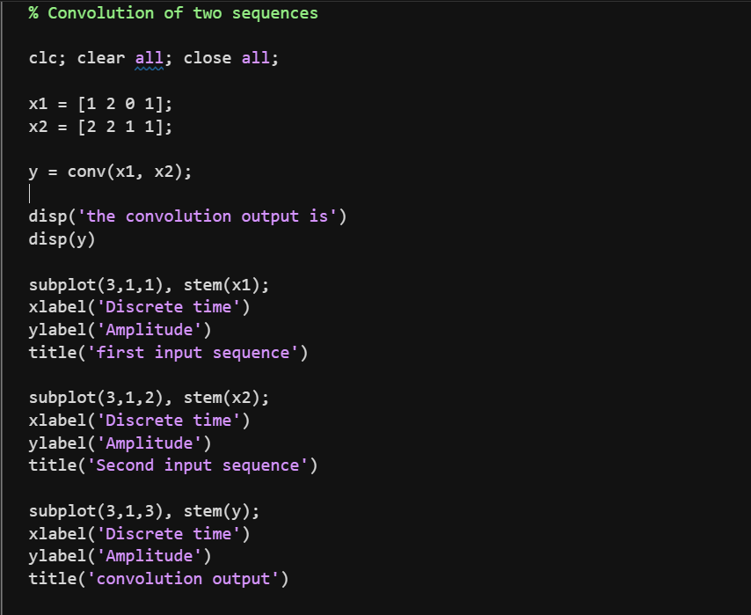

Output:
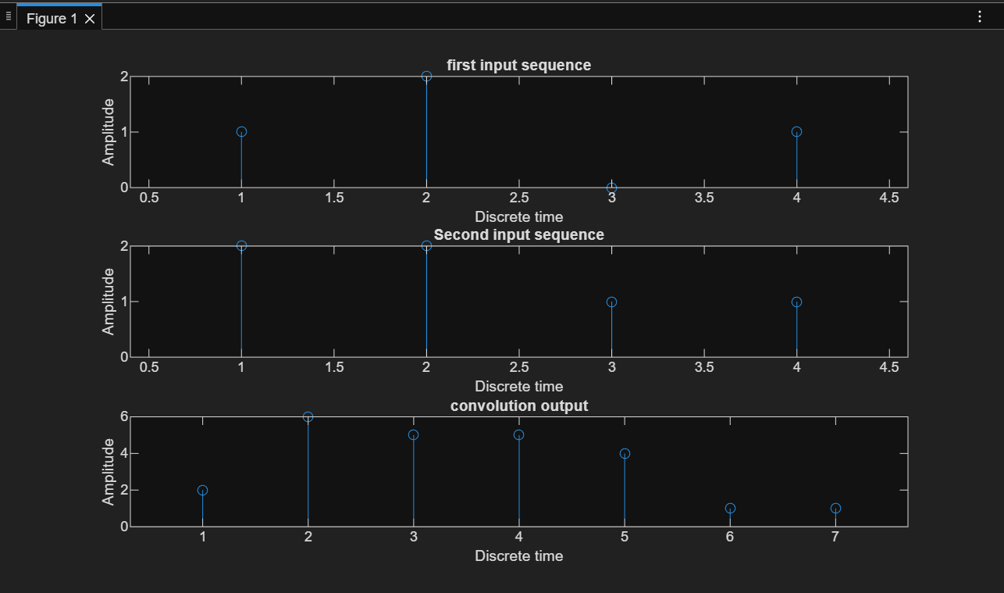
Program 2: Linear Convolution via Circular Convolution
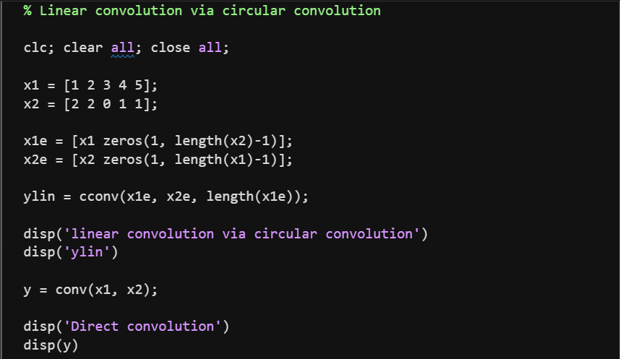
Output:
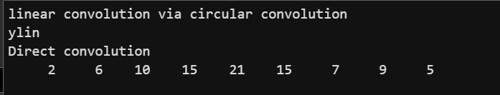
Program 3: Linear Convolution Using DFT
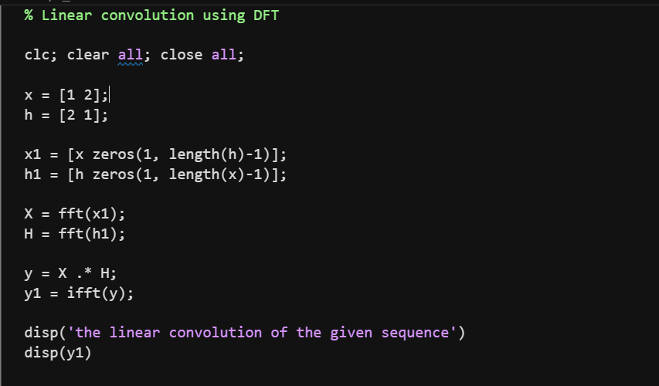
Output:
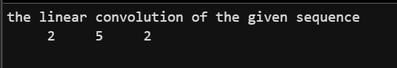
Result:
- Linear convolution was successfully obtained using direct, circular, and DFT-based methods.
- The outputs from circular convolution and DFT-based convolution matched the direct convolution result after proper zero-padding.

Conclusion:
This experiment verified that linear convolution of discrete-time signals can be performed using different methods such as direct convolution, circular convolution, and DFT-based convolution. All methods produced identical results when implemented correctly.

